**Manisha kc (final project work)**

**Presented to Iyalla John Alamina**

**Assignment of computing**

UML class diagram of shapes:-

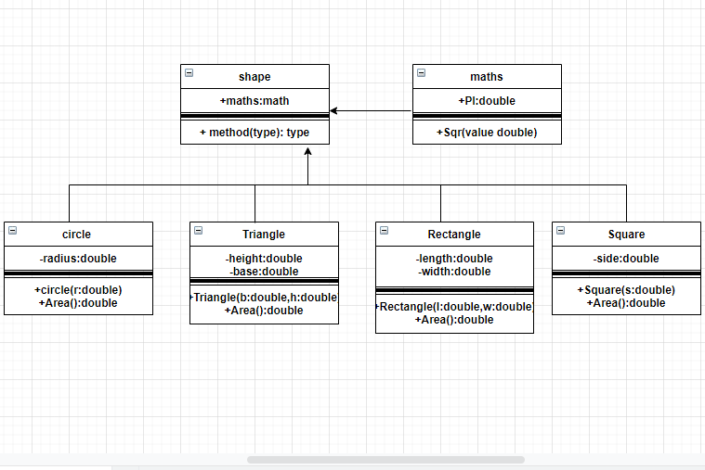

I did this class diagram on draw.io and took screenshots then attached over here. In this given diagram, there are six classes. Shape is associated further four classes like: circle, triangle, rectangle and square. In every sub-classes has methods and function. And circle has three members, triangle has four members, rectangle has four members and square has three members. And we have remaining one super class which is maths, which has included all the shape . It keeps attributes visibility private. Also I used ‘double’ which is shown and even decimals can be recorded. Similarly, I have implied radius, height, length, width, base, and sides which is used for circle, triangle, square and rectangle to calculate their respective area. And also given methods are as similar as class.

1. Main.cpp

#include <iostream>

#include "shapes.h"

int main() {

Shape s;

s.area();

}

1. Shapes.cpp
2. #include "shapes.h"
3. double Shape::area(){
4. cout << "Select a shape " << endl;
5. cout << "1. Circle " << endl;
6. cout << "2. Triangle " << endl;
7. cout << "3. Rectangle " << endl;
8. cout << "4. Square " << endl;
9. int choice;
10. cin >> choice;
11. enum shape {circle=1,triangle=2,rectangle=3,square=4};
12. switch(choice){
13. case circle:{
14. cout << "what is the radius? ";
15. double r;
16. cin >> r;
17. Circle c(r);
18. cout << "the area is " << c.area();
19. break;
20. }
21. case rectangle:{
22. cout << "what is the length? ";
23. double l;
24. cin >> l;
25. cout << "what is the width? ";
26. double w;
27. cin >> w;
28. Rectangle c(l,w);
29. cout << "the area is "<< c.area();
30. break;
31. }
32. case triangle:{
33. cout << "what is the height? ";
34. double h;
35. cin >> h;
36. cout << "What is the base? ";
37. double b;
38. cin >> b;
39. Triangle c(h,b);
40. cout << "the area is "<<c.area();
41. break;
42. }
43. case square:{
44. cout << "what is the side length? ";
45. double s;
46. cin >> s;
47. Square c(s);
48. cout << "the area is " << c.area();
49. break;
50. }
51. default:
52. cout << "invalid selection";
53. exit(0);
54. break;
55. }
56. return 0;
57. }
58. Rectangle::Rectangle(double l, double w){
59. length=l;
60. width=w;
61. }
62. Triangle::Triangle(double h, double b){
63. height=h;
64. base=b;
65. }
66. Circle::Circle(double r){
67. radius=r;
68. }
69. Square::Square(double s){
70. side=s;
71. }
72. double Rectangle::area(){
73. return (length*width);
74. }
75. double Triangle::area(){
76. return 0.5*(height*base);
77. }
78. double Circle::area(){
79. return math.PI*math.sqr(radius);
80. }
81. double Square::area(){
82. return math.sqr(side);
83. }
84. double Maths::sqr(double v){
85. return v*v;
86. }

3. Shapes.h

#include <iostream>

#include <string>

using std::cin;

using std::endl;

using std::cout;

using std::string;

class Maths{

public:

double PI=22.0/7;

double sqr(double value);

};

class Shape{

public:

Maths math;

double area();

};

class Rectangle:public Shape{

private:

double length;

double width;

public:

Rectangle(double l,double w);

double area();

};

class Circle:public Shape{

private:

double radius;

public:

Circle(double radius);

double area();

};

class Triangle:public Shape{

private:

double height;

double base;

public:

Triangle(double h,double b);

double area();

};

class Square:public Shape{

private:

double side;

public:

double area();

Square(double side);

};

Report:-

Introduction:

. The sample of the given c++ language is used to find the area of the given shapes; circle triangle, rectangle, square etc. The programming is divided into three parts, i.e, main.cpp, shapes.cpp and shapes.h . First of all we start the program by using ‘include’ function in the main.cpp file where integer and the title of the program is determined. The program is used to find the area of the shapes when user inputs the data. The user is asked to input the data (either radius, length or the factors determining the area of different shapes) using cout function and the data are stored using ‘cin’ function. The area of various shapes are calculated with the help of this program.

Objective:

This given programing apparently shows that to find the area of every shapes. Talking about the main.cpp it says firstly we determine the code of shapes and indicates to calculate area of different shapes. Similarly, we have next shapes.cpp where I used ‘double’ coding and used cout for select a shapes like circle, triangle, square and rectangle. Firstly, I used ‘cin <<’ value of radius which gives result as you can see on programming of circle. Similar way, for rectangle I commanded the ‘cin <<’ for length and width which gives value of area then break and using middle bracket(}). And also I have used the same thing in triangle again got the instant result area of triangle. When I used the double height, double base it makes the coding more easier to get results. As a same way in shapes.h I used ‘std:: cin, endl, cout, string. And used super class(maths), then public where I assumed the value PI=3.1415 then used sqr(double value) after ued middle bracket(}). This super class included every shapes like circle, rectangle,square etc. In rectangle firstly I made class of rectangle(public shape) and opened { and used in private: then I have used the formula of rectangle length*width after that I did public: the code then used double area(); and closed the }, which gave me result of rectangle. In a same way I have used in triangle, using public shape and kept programming in private and used the formula of triangle height*base and started use double height, double base then use command of double area and closed bracket. Which has given correct results like shapes like circle and square.

Algorithms and flowchart of shapes:

Flowchart of Rectangle

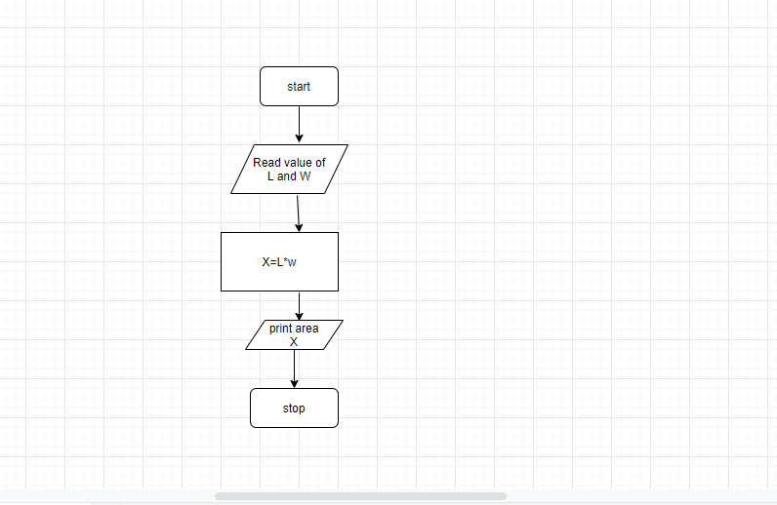

Algorithms of Rectangle:

* Step1: Read input W,L
* Step2: X= W*L
* Step3: print X

Flowchart of circle

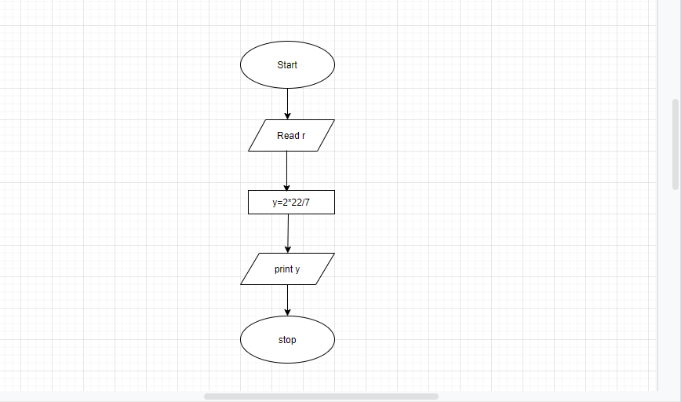

Algorithms of circle

* Step1: start
* Step2: read r
* Step3: calculate y=2*22/7
* Step4: print y
* Step5: stop

Flowchart of square

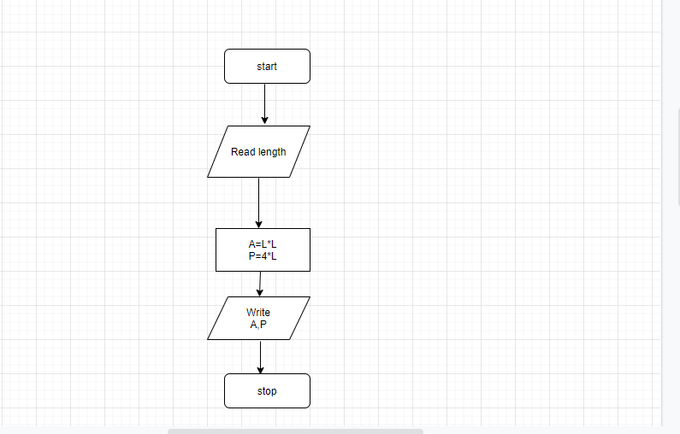

Algorithms of square

* Step1: start
* Step2: read length(L)
* Step3: Area A=L*L
* Step4: Perimeter P=4*L
* Step5: print A,P
* Step6: stop

Flowchart of Triangle

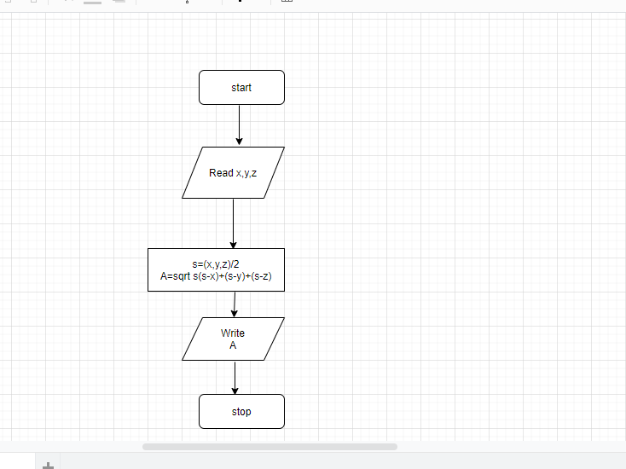

Algorithms of Triangle

* Step1: start
* Step2: read x,y,z
* Step3: s=(x+y+z)/2
* Step4: A= sqrt(s*(s-x)*(s-y)*(s-z))
* Step5: display A
* Step6: stop

Conclusion:

The program aims to help find the area of different shapes(circle, triangle, rectangle and square). The use of class diagram c++ language, flowchart, algorithms are used during the process. The program find s the area of the any given shapes when the user inputs the data of the measuring factor. So, this program overall find to help the area of shapes.